Crimean Tatar Language Digital Resources

Set-up on Windows OS

*This guide provides instructions for ordinary*

*users and developers/publishers*

*who wish to implement support for*

*the Crimean Tatar language in their*

*products and services.*

by <https://x.com/BohdanDesna> (version 1.1)

This material is intended for non-commercial use only. All information presented is based on publicly available sources from the internet. The author has made a reasonable effort to ensure accuracy, but this work does not constitute professional advice. Users are free to share and distribute this content under the terms of the Creative Commons Attribution-NonCommercial-NoDerivatives 4.0 International (CC BY-NC-ND 4.0) license. This allows sharing the verbatim content for non-commercial purposes only, with appropriate credit given. No modifications or derivatives of the work are permitted. Please verify any critical information, as the author does not guarantee the completeness or accuracy of all content. This material is provided as-is without any warranties. The author is not liable for any damages arising from use of this information. For professional use, please seek guidance from qualified experts in the relevant subject areas. Thank you for respecting these terms.

**SET-UP**

Set-up keyboard layout on Windows 11© Step-by-step guide

1. **Download the Layout:**

* Go to your web browser and visit:<https://keyboard.aveteam.org/home>
* Click the blue "Download" button. This will download a zip file to your computer.

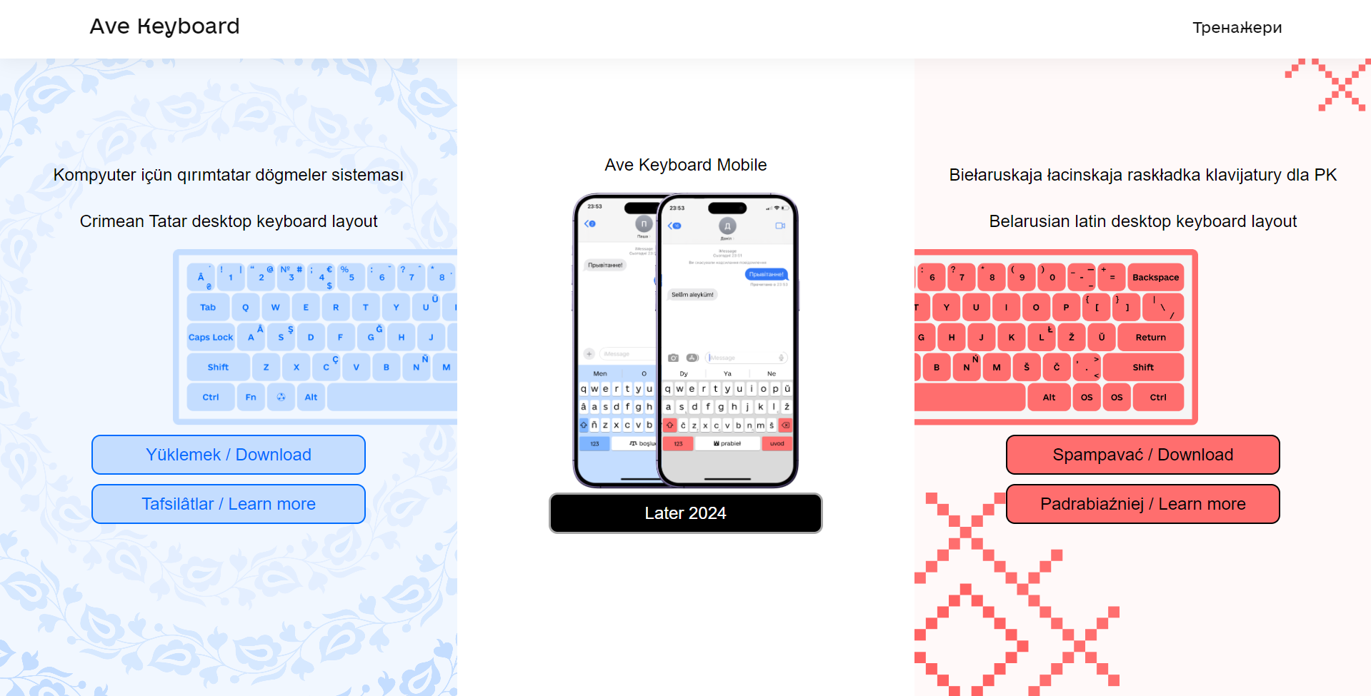

1. **Extract the Files:**

* Locate the downloaded zip file (usually in your "Downloads" folder).
* Right-click on the file and choose "Extract All."
* It's recommended to extract the files to the same "Downloads" folder for easy access.

1. **Install the Layout:**

* Open the extracted folder.
* Double-click on the installer file (usually an .exe file).
* Select the second installation option and click "Встановити" (Install).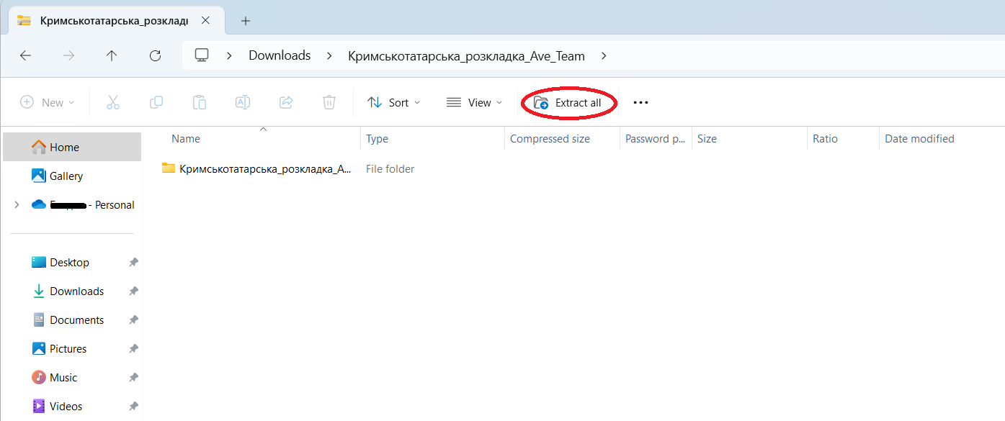
* After opening the folder open installer
* Select second option and press “Встановити” that means “Install”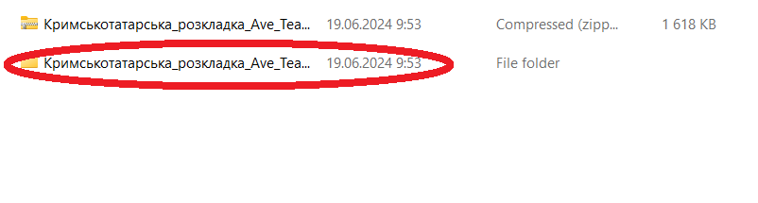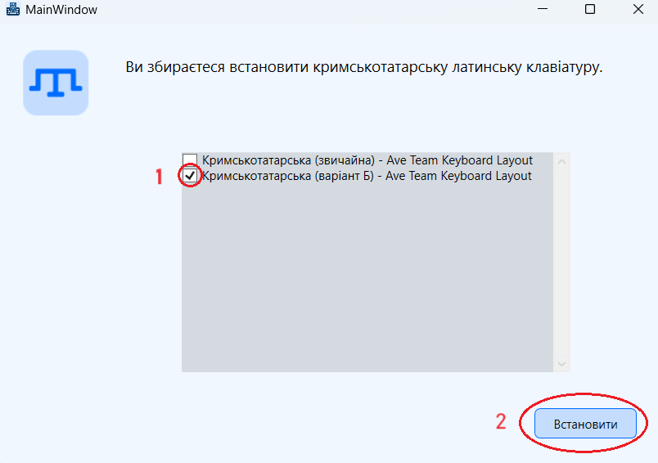

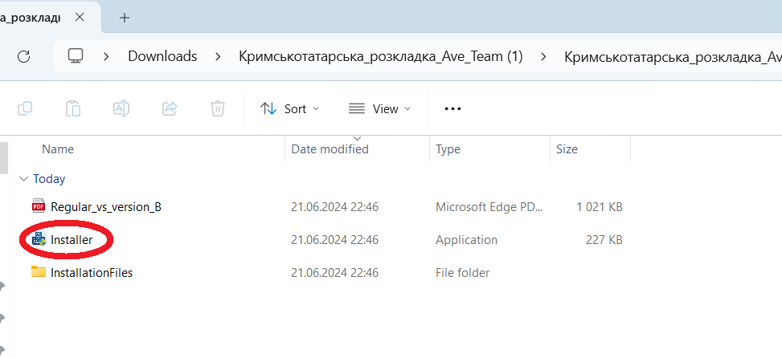

1. **Restart Your Computer:**

* You've now installed the keyboard layout! Restart your computer to apply the changes. Click "перезавантажити зараз" (Restart now).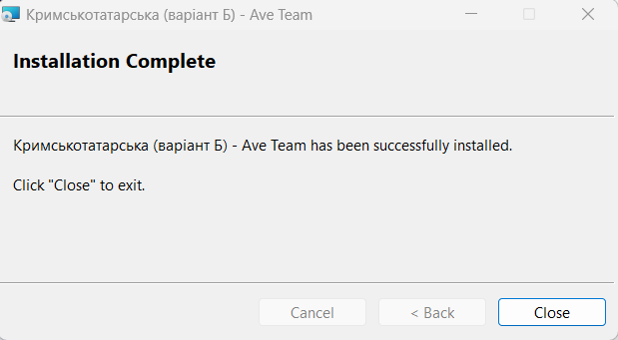

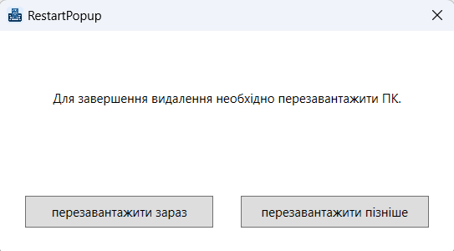

1. **Verify Installation:**

* After restarting, go to your Windows settings. You should see the new layout installed, likely listed as Turkish. This is normal, as it includes all the special characters needed for Crimean Tatar.

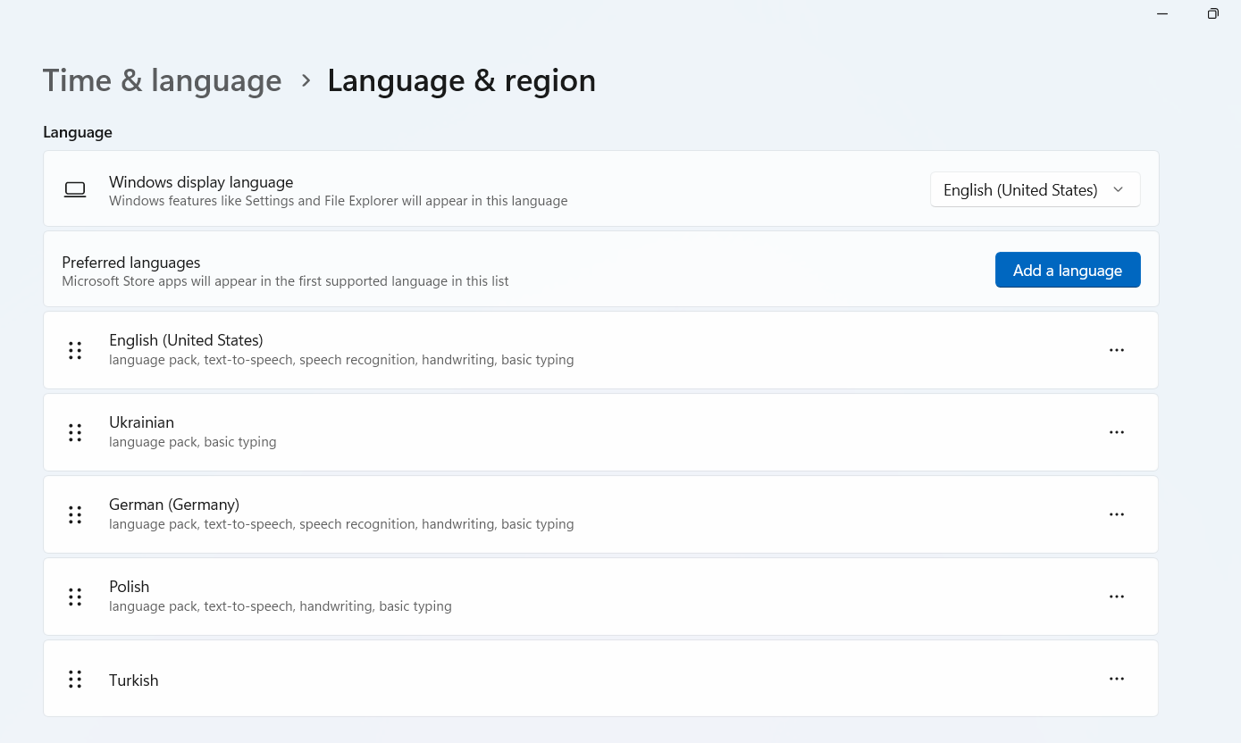

**Special Character Combinations:**

| Character | Key Combination |
| --- | --- |
| i | Right Alt + ı |
| İ | Right Alt + Shift + ı |
| ü | Right Alt + u |
| Ü | Right Alt + Shift + u |
| ö | Right Alt + o |
| Ö | Right Alt + Shift + o |
| ş | Right Alt + s |
| Ş | Right Alt + Shift + s |
| â | Right Alt + a |
| Â | Right Alt + Shift + a |
| ğ | Right Alt + g |
| Ğ | Right Alt + Shift + g |
| ç | Right Alt + c |
| Ç | Right Alt + Shift + c |
| ñ | Right Alt + n |
| Ñ | Right Alt + Shift + n |

**To Switch Languages:**

Press Spacebar + Windows key to toggle between your installed keyboard layouts.